Robotics Project 2
Ruixuan Pan
- To create an environment first install the navigation package
Run the SLAM
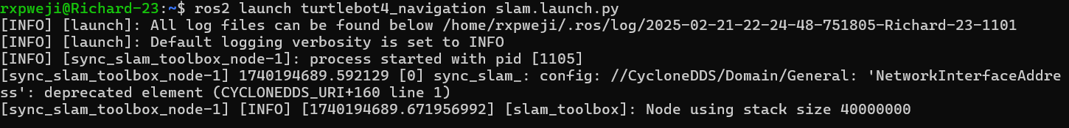
Launch Rviz to visualize it
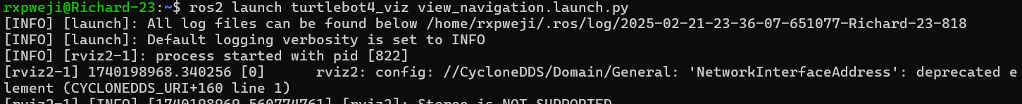
- To set up the environment, I used the code below to create a launch file
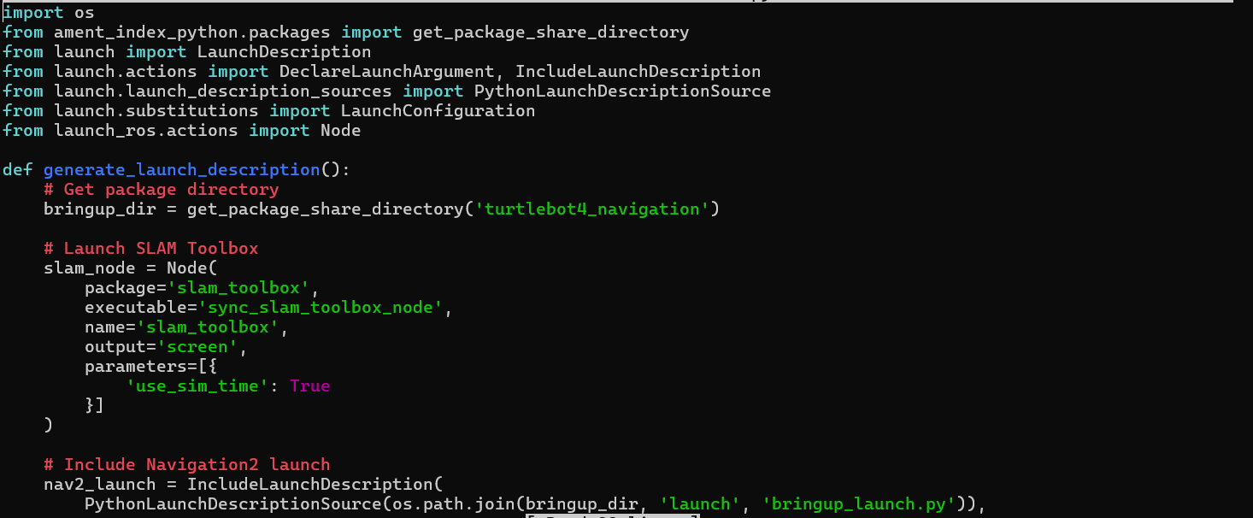
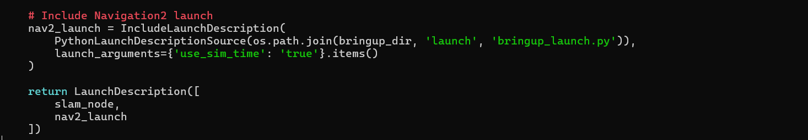
After that I sourced it into the package with code “colcon build --packages-select turtlebot4_navigation
source install/setup.bash”
Then Type in ‘ros2 launch turtlebot4_navigation turtlebot4_slam.launch.py’ to open it up
- To get the robotic moving, I implemented the code with Teleop_Twist_Keyboard where the messages are received as /cmd_vel to tell the robot to either move linearly or with angular velocity
- The biggest challenge would be to connect to the robot with connection and move it according to the instructions provided from the nodes; to do so I have adjusted the speed of the robot moving and figure out the velocity using linear.x and angular.x that will move the robot from one corner to the other.
- To ensure that my node is running properly, I type in ‘ros2 topic list’ and ‘/cmd_vel’ should appear, then as I type in the keyboard indicates, it should returns the message such as how much I am moving in x, y, z direction or the current velocity after the increment by 10%, once these appear, then I know the robot is receiving the message and move accordingly.

